Location of the Art Class:
159 Crestridge Drive, Vernon CT, 06066
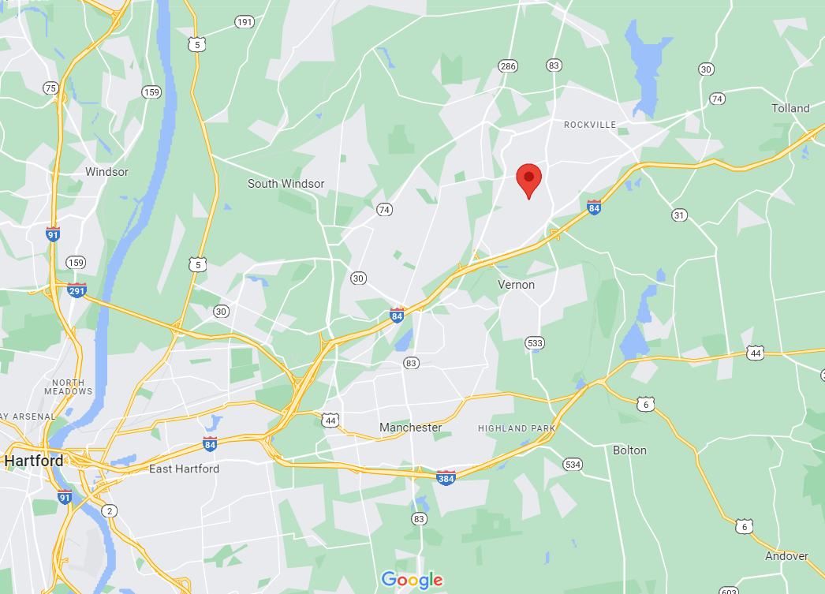
Driving W: Interstate 84 get off at exit 66 (Tunnel Rd) Turn R on Furguson Rd./CT542. Turn L on Bolton Rd/CT541. Keep straight to Center Rd. crossing CT30. Pass the school. Straight after the Stop sign. 2nd street on the right is Crestridge Drive.
Driving E: Interstate 84 get off at exit 66 (Tunnel Rd) Turn L on S Frontage Rd./CT541. Turn L on Bolton Rd/CT541. Keep straight to Center Rd. crossing CT30. Pass the school. Straight after the Stop sign. 2nd street on the right is Crestridge Drive.
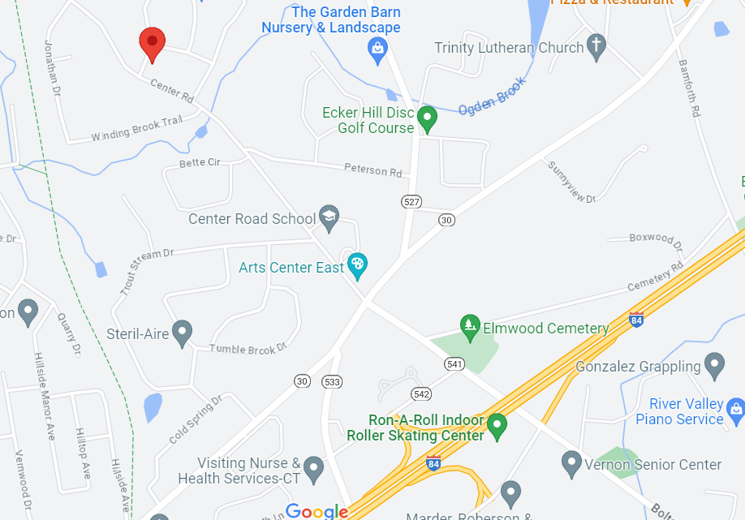
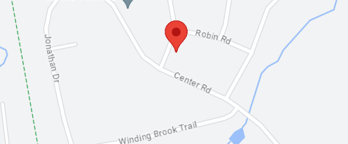
Tan house with Blue shutters. Park on the road in front of the house or in the driveway. Use the front door.
Classes are in the basement.
